Picasa 3 Lynda.com

Introduction
Welcome

In this course we will show you how the power of this free download from Google will make it easy to organize, edit, and share your photos with families, friends and the world. First we will show you how to download Picasa 3. We will look at importing assets and exploring the new desktop photo viewer. Then we will get into the good stuff: editing tools for retouching, and automatic correction. We will show you how to tint your photos, add captions to them and even fast edit images. And of course we will go over several ways to share your photos on various platforms. We will show you how to publish your photos on a mobile device or even get them into print. Plus we will even show you how to use the Picasa tools to edit video. We will show you how to create and edit web albums. We would show you the new face recognition functions to locate and organize your photos.
Using the exercise files

1. Getting Started
What's new in Picasa 3

There is a lot new in Picasa 3. It was a huge update from Picasa 2 including the ability to synchronize edits between Picasa and web albums, retouching images has become increasingly easier as you remove blemishes, previewing images is even easier with Picasa desktop viewer, you can use it in specific file formats to override your image editor, you can opt in and out of it at any time, and you can use it outside of Picasa. You can create and edit movies in Picasa 3. This will allow you to create and edit and export your own movies. It will even allow you to export them directly to YouTube. In addition, there are greater text controls. You can add watermarks to your export or position multiple layers of text inside your photos themselves. In addition, uploading has been made easier to Picasa Web albums. Global settings and setting all of your privacy controls is even easier. There is better folder management to edit, move and easily flow between your folders. There is greater control for raw image processing. All edits are nondestructive. The new Cropping Assistance helps you start with great suggestions on what might be a great crop. In addition, there is great dynamic online screensaver support. In addition to the tagging, there is multiple keyword support. There is also improved importing. When you plug in your camera, it integrates by date allowing a better interface. The collage tool has a lot of updates including multiple templates and adjustments. Finally, One Step Sharing helps consolidate the upload and email task into one easy step.
Downloading and installing Picasa on the PC
Let’s talk about installing Picasa from scratch on the PC. Open the browser of your choice and go to Picasa.Google.com. The browser will automatically detect which platform you are on, Windows, Linux, or Mac and download the appropriate version.
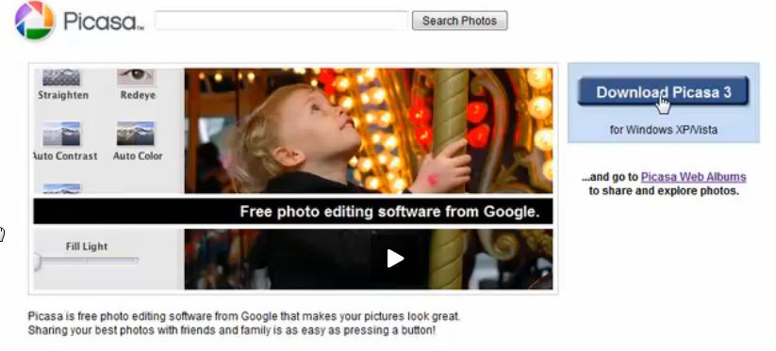

You will be presented with a dialog box. Code ahead and click on the save button.

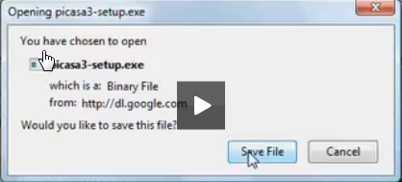
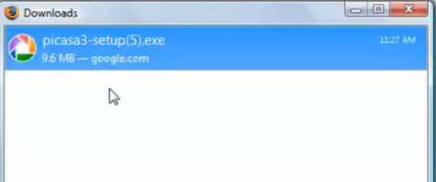

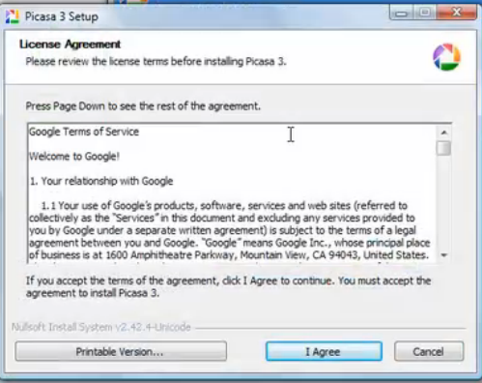

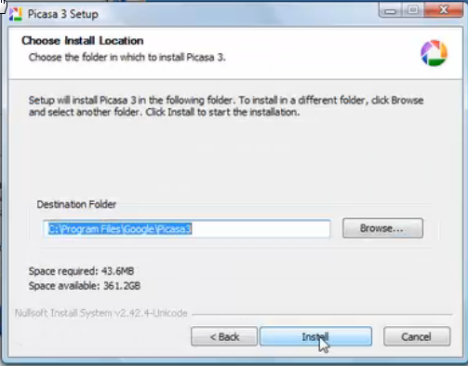

This should download rather quickly. Once it is complete, double-click on the executable. You will be presented with the license agreement. Make sure you are comfortable with the license agreement and click on “I agree”. The next step is to make sure the destination folder is where you want to store the program on your machine and then click install.

You will be presented with a couple of choices.

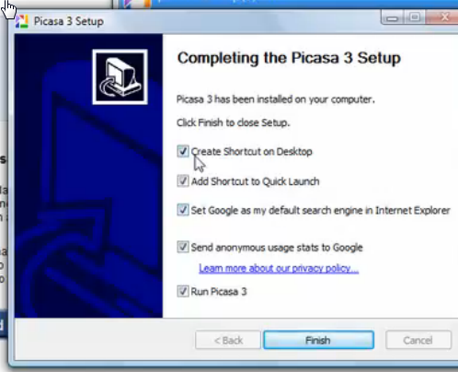

You can create a shortcut on your desktop, add a shortcut to the Quick Launch, set Google as your default search engine in Internet explorer, send anonymous usage stats to Google, and also to Run Picasa when you click the finish button. These are all choices that you have to make.

The next step is to decide where you want to scan for your photos. People may keep their photos in different folders or locations.

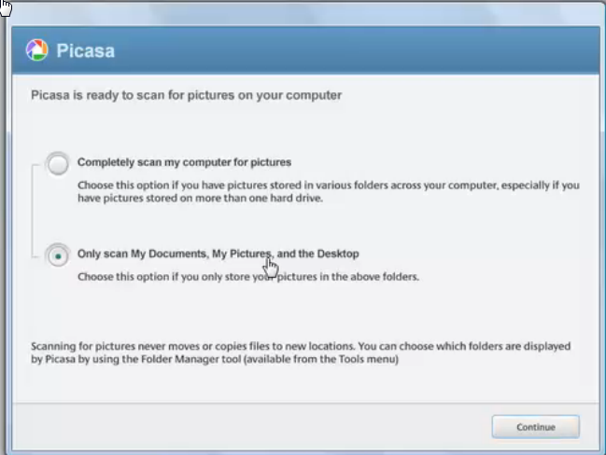

I would suggest that you start by only scanning the My Documents folder the My Pictures folder and the Desktop.

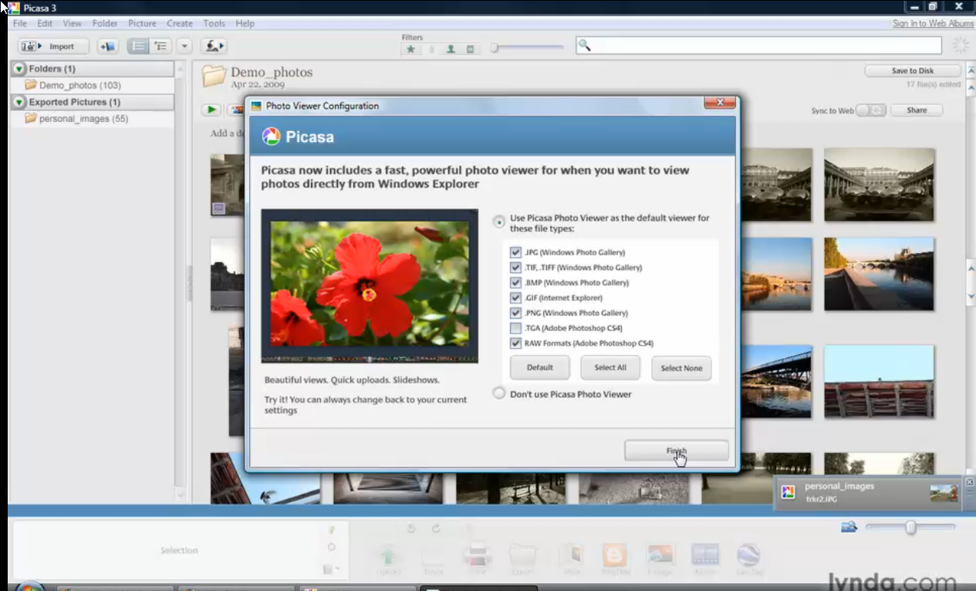

Notice that in the lower right, the pictures will be pulled in automatically. What’s new and Picasa 3 is the Photo Viewer. You can configure what images you want to make Picasa the default viewer for or you can opt out of it at the bottom. If you choose Picasa, that will overwrite any default photo viewer that you have. So make this choice carefully.

2. Image Library Basics
Organizational paradigms
Once you open Picasa 3 there are a few things to consider regarding organization.

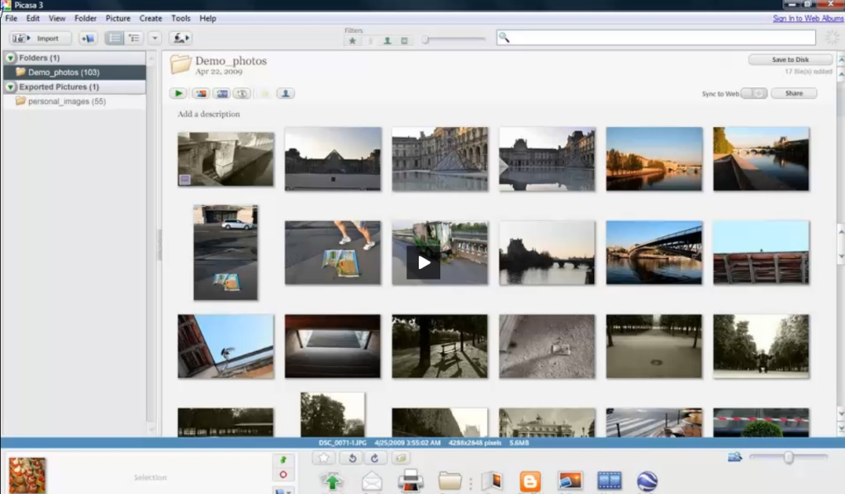
The first thing to understand is a relationship between Picasa and the file system. When you select a photo, it will get added to the photo tray. You can either hold down the control key to select individual photographs or hold down the shift key to select a group of photographs.

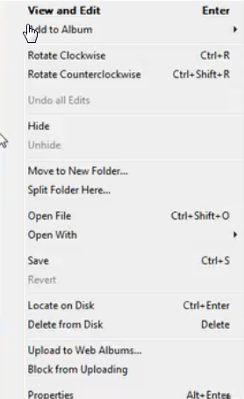

If you right-click on an image that you have selected you will get this dialog box. You could select, “Move to a new folder” and then you would get this dialog box.

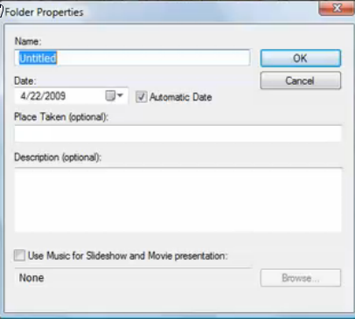

Obviously, the first thing you would do would be to give it a name. It will default to a date that corresponds to when it was taken. There is option to enter where it was taken. This corresponds to Google Maps. If you wish, you could also enter a general description. Also, if you are creating a slideshow you could click the option to use music. After you have selected your options, click okay.

You will notice now that there is a new folder created.

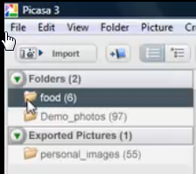

If you have Picasa import all of your photographs, they will be in the timeline. You can quickly find them by clicking on View >Timeline.

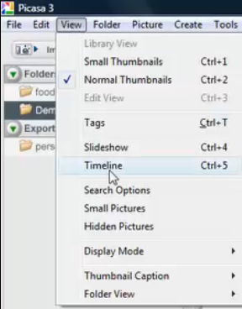

This will take your program into a timeline mode and allow you to navigate for your images. You can escape the timeline by pressing the back arrow at the lower left.

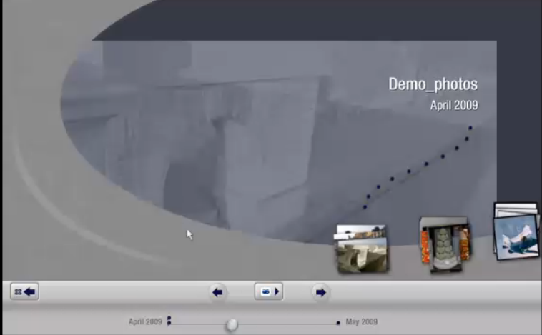

You can click this button to show the tree structure if that is more of the ways that you like to see things..

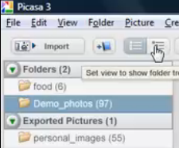

The last thing we want to talk about is adding new content. If you want to add a folder you click: File >Add new Folder as shown below.

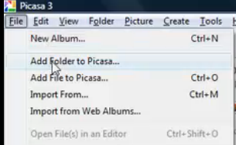

This will bring up the folder manager dialog box.

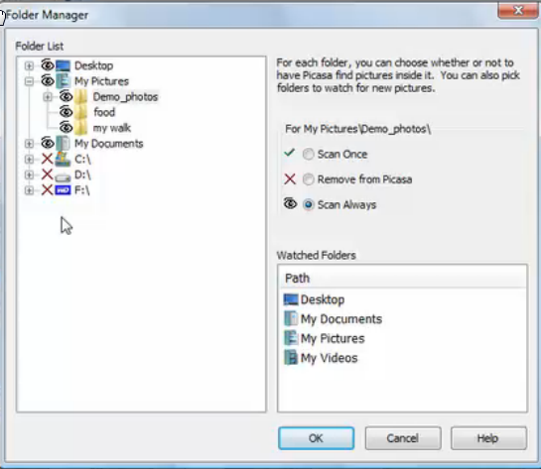
You can highlight any folder and then you have choices to either: Scan once, remove from Picasa, or to scan always.

A second way is to click on the “Tools” and then pick folder manager.

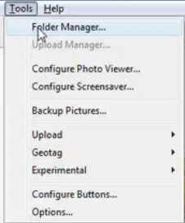

Exploring the interface
Now it is time to explore the interface. You use the left-hand column to navigate the folders. By clicking the individual folders you open them up in the picture viewer on the right-hand side.

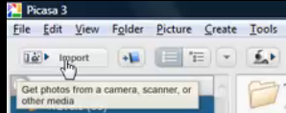
Along the top, you have buttons that will correspond to different types of actions that you can take.

You have an import button that will allow you to connect to a particular device or hard drive. You can directly create a new album. The next button allows you to change the folder view. Then the drop-down arrow gives you different choices for how you want to sort your photos. Then lastly, if you have a WebCam, you can use that directly to import photos into Picasa. In the middle you have buttons to use the very powerful search features of Picasa.



You can search on anything within the metadata itself. If you wanted to search for all of your raw files all you would have to do is to type in the extension, i.e.,.NEF. There is one icon to search movies only. Or, one of the things that is very valuable is to search by facial recognition. This has been greatly improved in Picasa 3. When you are sorting your photos, you can give them a star rating. Using the search methods you can search for those photos that you have given a star.

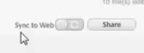
There is a new tool that allows synchronization between web albums and the program, Picasa itself. This gives you the ability to save to a specific disk or to coordinate with the web album itself.

The central area is the navigation pane. You can scroll through your pictures with the slider on the right. It will speed up and slow down the more you move the progress bar. You can also use the scroll wheel on your mouse.

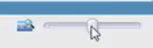
In the lower right is a control which will let you zoom in or zoom out on your photographs just by sliding the bar.

The last tray at the bottom is the task pane. It allows you to do specific actions on the photos themselves. Once items are selected you can group them into specific tasks.

Using the Task tray
As you click on specific images in the task pane, you’ll add them to the photo tray.

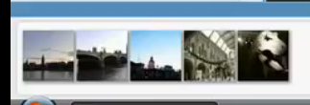

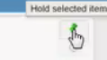
If you want to keep those photographs in the task pane while you navigate to other folders, be sure to use the hold button. This will place a circle in the lower left of the photos to show you that they have been held.

The default tasks are: uploading to Web albums, emailing, printing, or exporting them to another location on the disk. There are additional services like: shopping, blogging, making a collage, selecting move, or geo-tagging the photographs. Many of the newer cameras offer geo-tagging as you take the images.

Adding a custom button to the Task tray
Exploring the Help and Tools pull down menus

Importing photos and movies from a camera or card reader

Next we will talk about connecting your card reader or camera to the computer. You may have a card reader slot on your computer or you may have a USB flash drive that you can plug your card into. Of course you can always just plug your camera directly into the computer but this will use the battery on your camera. If you have “Auto Play” turned on this is what you will see when you plug in your camera or your card reader.

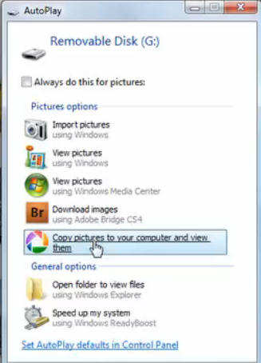

If you don’t have “Auto Play” turned on you can click on the import button.

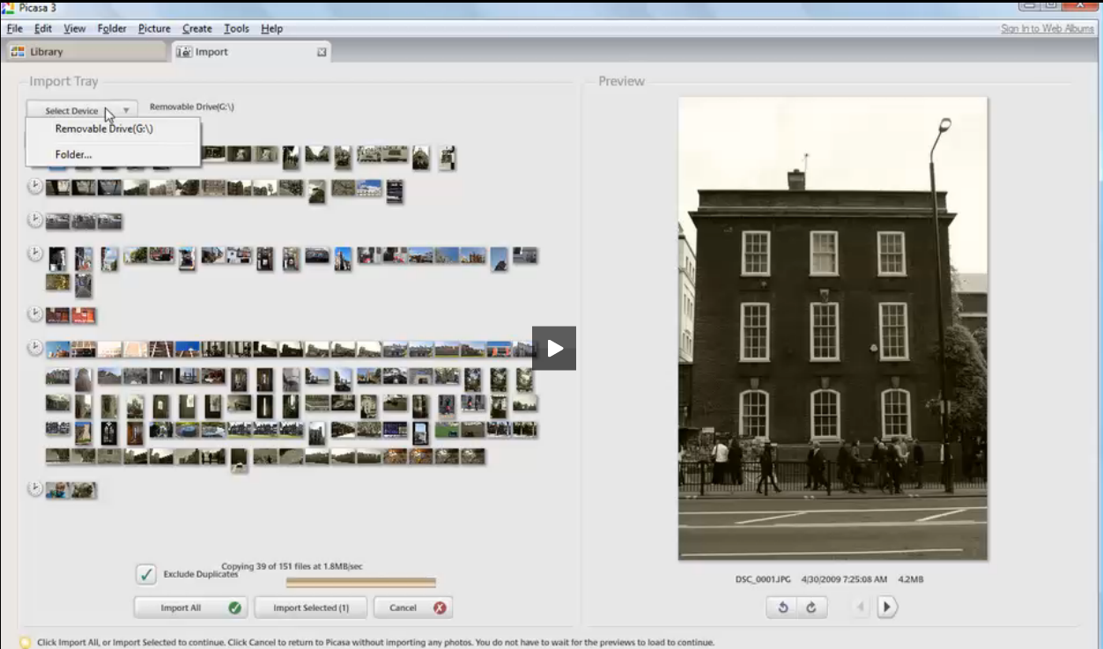

This is one of the places the Picasa three has been improved. First of all you will notice that there is an ability to pick between the different devices. There is also a delineation by date. As you hover over the arrows on the left a pop-up box will show you the date taken. If you want to select multiple days to import just use the control button as you click. Another very helpful feature is the checkbox to exclude duplicates in the bottom left. Sometimes you just want to import everything and you can click on that arrow in the bottom left. Or, you just want to import what you selected and you can click on that button.

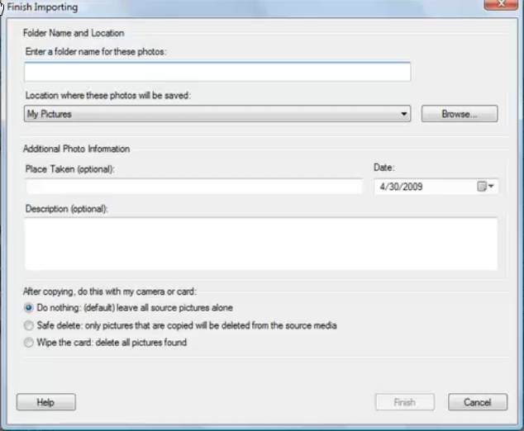
That will open up the import dialog box. It will ask you where you want to put the new photographs. You can enter a new folder name or browse to a location. It will set the folder up with the default date from the metadata. Also, you can type in a location and later you can search by location for your pictures. Additionally you can add a description which you can also use for searching later. The bottom is very important. 02:58

In the bottom left you can choose what you want to happen after the import. The default is to “Choose Nothing”. Most people recommend that you use this choice. Make sure that the pictures have transferred to your computer before you delete them from the camera card. Also, it is a good idea to format your camera card in the camera instead of just deleting the pictures. This will help your camera card to last longer.

javascript:void(0);
Remembering your memories
Using the new Desktop Photo Viewer

Typically if you were to search your my pictures folder and then open up a specific folder of pictures and click on it the picture would open up in the Windows photo viewer. If you have not set up Picasa to be the default photo viewer you can always go and click on tools in the menubar and then click on configure Picasa Photo Viewer.

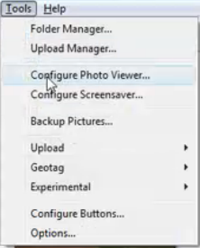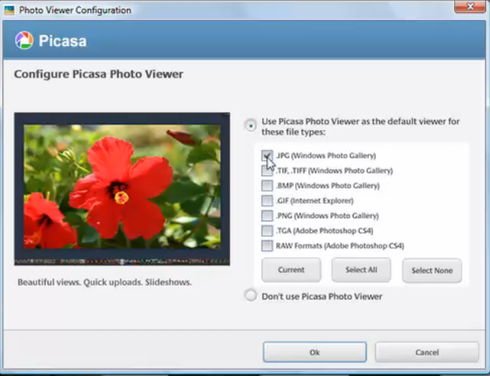

That will bring up the Photo Viewer configuration dialog box. You can click any of the photo types and then click okay to make the Picasa photo viewer your default photo viewing software. The Picasa Photo Viewer has been features that are not available in the Windows photo viewer. The first thing you may notice would be orientation. If you rotate a photo in the Picasa Photo Viewer it will remain rotated when you open up the Picasa image editor. That does not happen in Windows. You can also apply star ratings in the Picasa Photo Viewer that will show up in the image editing software too. You can also select a photograph and then directly edit it in Picasa.

3. Organizing Photos
Using folders and albums
Tagging and rating your photos
Using filters effectively
Searching for photos
Deleting, hiding, and removing photos
Creating and editing a new online album
Screen captures made easy

4. Editing Photos
Using the Basic Fixes palette

This is where the fun begins. To get into the photo editing mode, just double-click on any image in the file browser.

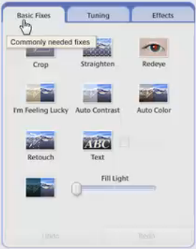
There are three tabs in the editing dialog box: Basic, Tuning, & Effects. This has most of the basic controls in a logical sequence. Usually the first thing you want to do is crop and straighten. I like to do straighten before crop. When you straighten, some of the image will be outside of the normal rectangle. It is also very easy to remove redeye. If you wish you can add text. If you have a photo where the light was bright behind the image such as someone standing in front of a window, or someone with a hat over the head in their faces and shade, you can use the fill light to brighten them up. This is very handy.

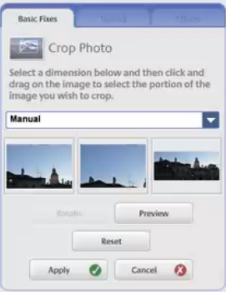
In the crop dialog box the present three choices and as you hover the mouse over the choices you can see the picture. You can also move the choice by clicking in the middle and just dragging your mouse. If you want a standard size such as an 8 x 10 you can click the manual button and choose the size or create a custom size. You can also see a preview by clicking the preview button. One of the nice things about Picasa is that none of the image edits are destructive. You are not changing the pixels in the basic image. You are writing all the information to a sidecar file. This is very important for image preservation. Previously you would have to make a copy and just edit the copy and other software programs. You can also drag the crop by the edges or tops or corners.

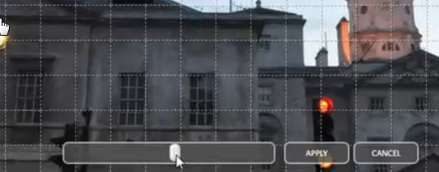

You can also straighten the image. When you click on that option you will get a grid over your image and you slide the button right or left to straighten the image to the grid. You can use the vertical or the horizontal lines to straighten the image.

You can click on any of the other icons to see what they do and then just click undo if you do not like it. You will notice that at the top of the edit box is a filmstrip of your images. You can use this very quickly by using the right or left arrow keys.

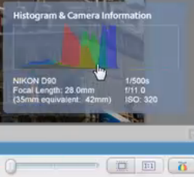
By clicking on the button in the lower right of this image you can bring up the histogram. You can also edit raw files in Picasa. The histogram will tell you if you have blown out any highlights are blocked up any shadows. Then you can use the edit options to optimize the Dynamic Range of the image.

Using the Tuning palette

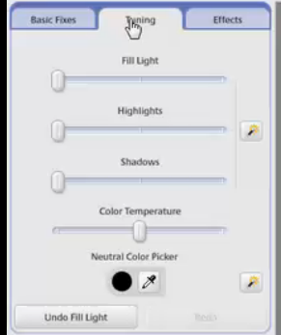
The Tuning Box is very similar to the camera raw adjustments in the basic tab. You have Fill Light which will adjust the midtones in the histogram, Highlights which will adjust the bright areas, and Shadows to adjust the detail in the dark areas. You also have the ability to tint the image using the color temperature slider. Sometimes you want the picture more warm and sometimes more cool. If you need to get more detail you can choose the color picker. The neutral color eyedropper is also very helpful. If you click on that, then try to find a color in the image that is either gray, white, or black. When you click on that it should do an AutoCorrect for the color. The icon at the right is an automatic to adjust all of the options. Sometimes it is a good place to start.

Using the Effects palette

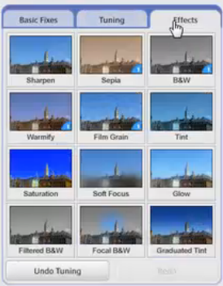
The final tab is the Effects Palette. This is a series of effects that can overlay in a nondestructive way on a JPEG or a raw image. Sharpen is something that every digital image needs. There is an anti-aliasing filter in front of most low and midrange cameras. This stops "jaggies" from happening in your image. Also, the Bayer pattern in the sensor has to have a demosiac process applied to it. Both of these processes tend to blur the image slightly. The amount of sharpening you add depends on the final output. If you're going to output to the web you should only get a little sharpening. If you're going to print, you should add sharpening until the picture looks a little over sharp. This is because of dot gain when ink is applied to the paper. When you bring an image up try the special effects to see what you like.

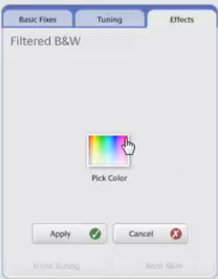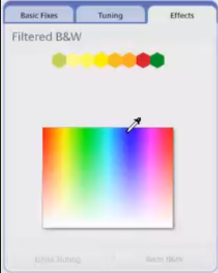

The filtered black and white tab allows you emphasize the grayscale in the image. You click to pick a color and then the color box pops up shown on the right above. This is an active process. As you move eyedropper over the different colors you can see the affect in the view pane. This is very helpful if you want to pull out different parts of the image. The sepia effect will basically give you a single tone. However, you can choose what you want by using the “Tint” option.

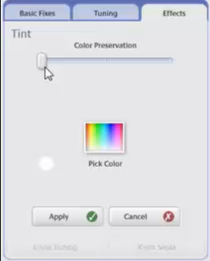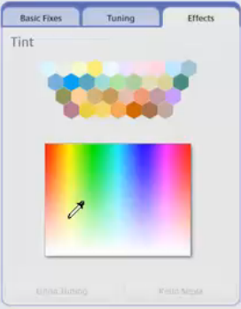

On the left is the first tent dialog box. On the right is what you will get when you pick a color. As you hover the eyedropper over the different colors you can see the effect on your open image. After you click on a color that you like you can use the Color Preservation slider to bring back the basic image color as much as you want. If it is too saturated, you can open up the Saturation Tab and adjusted to your liking. Remember, all of the edits in Picasa 3 are nondestructive. If you want to get back to the original all you have to do is click the undo tabs. It is fun to experiment with different combinations of effects. They build one on top of the other.

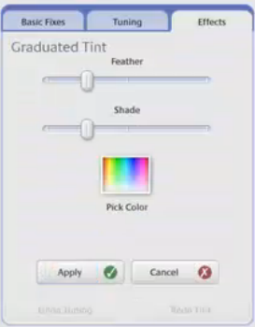
Another option is to use the graduated tint feature. You can pull down the graduated tint to add some deeper blue to the sky. When you adjust the Feather, you will change how soft the border is from the top to the bottom. By moving the cursor left and right you can also adjust the angle. This is helpful if you are shooting a horizon that is not level such as a mountain.

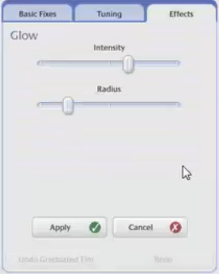
Another interesting effect is the Glow effect. This gives a little bit of softness around the whites. For those who are interested in absolute sharpness, this may not be your choice.

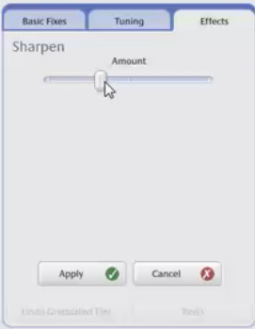
All digital images need to be sharpened. It is best to sharpen at 100% image view to see the effect.

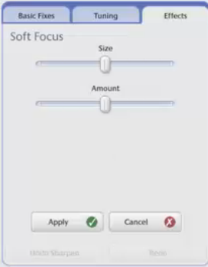
Another fun effect is Soft Focus. This gives you a chance to drag an area around the screen to emphasize your focus. You can adjust the size and the amount. Some people like to do this for portrait or flower photographs. It is interesting if you want to highlight a specific part of the image to be in focus. It is a bit like an adjustable depth of field.

Using the Retouch tool

The Retouch Tool is used to remove blemishes, marks, dust etc. You find it under the basic tab.

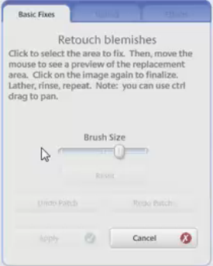
The slider allows you to adjust the size of the brush for the blemish that you want to remove. Move the circular brush to a spot that you want to remove. That will select that spot. Then move the brush to a spot that you want to "clone" from. This is not as accurate as the spot removal or the cloning tools in Photoshop or in Elements but it is a simple way to try to clean up your images a little bit without paying a lot of money for a complex program.

Applying red-eye repair

Red Eye happens when you’re flash goes off and you get a reflection from the retina of the eye. On people it is red. On my dog it is blue. This is very troublesome with most point and shoot cameras because the flash is so close to the lens. Many cameras have a choice in the flash menu to decrease redeye. This is supposed to prefire a small flash to help close down the iris. I have not found this to be very effective. However, the red eye fix in Picasa works very well.

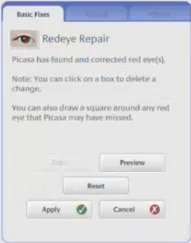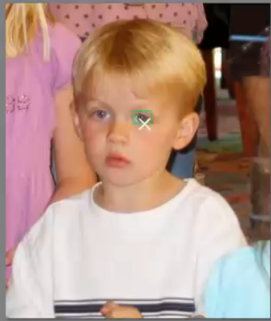

Again this is more helpful if you enlarge the image. Then you just place your cursor over the area that you want to correct and click. Then you can draw the cursor to expand or contract the area to once you want to use. Then you can preview before you actually apply.
Flirting with black & white, sepia, and tinting

After you convert to black and white, go back to the Tuning Tab and adjust the fill lights, highlights, shadows, and even color temperature to enhance the affect. Also, use the Filtered black and white option. This will highlight areas in your image. Even be graduated tint works well on a black and white. Also try with warming or saturation.
Effective cropping and straightening

Sometimes you can create an interesting effect by tilting the image using the cropping and straightening tools. You can also try to use the crop tool to create a panorama picture.
Adding captions, text, and watermarks
Using effects effectively
Batch-editing for speed

5. Sharing Photos
Creating and playing a slideshow
Creating gift CDs
Uploading photos
Emailing photos
Using the Share button to upload and email photos at the same time
Setting printing controls for local printing
Exporting photo
Advanced exporting to HTML galleries and Flash
Customizing your export templates
Reordering and customizing your share buttons
Printing commercially
Creating a collage
Creating and editing movies and uploading to YouTube
Blogging photos quickly using BlogThis!
Creating a blog post via email
Sharing via Facebook
Sharing via Flickr
Uploading photos to SmugMug
Posting photos from iPhone to your web album
Viewing web albums on the iPhone
Downloading and synchronizing web albums
Turning a web album into a live RSS feed

6. Picasa Web Albums
Getting started
Creating web albums
Organizing and reordering albums
Deleting an album
Adding locations to albums and images using the Album Map
Adding captions to albums
Adding tags in web albums
Changing General settings
Changing Email Notification settings
Changing Privacy and Permissions settings
Changing Storage settings
Identifying people in photos using face recognition
Sharing web albums
Downloading albums and downloading images
Creating projects using the Download tab
Ordering prints

Conclusion

